

Dr. Stephanie, Garza inc.
2016-01-27
Dr. Garza
568 Nicole Hills, New Jamestown, MD 42604
Phone: 9326192896
Fax: 3036407357

Re: Michele, Michael
PHN: 4157632149
Birthdate: 19-Jul-1953
Address: 362 Green Plains Suite 369, Wilsonview, WV 26376
Patient number: 663024548

To Whom It May Concern:

This is a medical letter to state the above patient is pregnant with expected delivery date of 26-Sep-2025. Hoping this information is satisfactory for your requirements.

Thank you.

Sincerely,
Dr. Stephanie, Garza
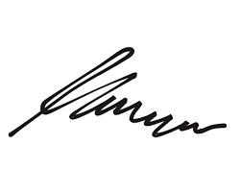
FRCS© NCMP
Clinical Assistant Professor, UBC
Department of Obstetrics and Gynecology SMH

